FINAL PROJECT REPORT

(PROGRAMMING FUNDAMENTALS-Lab)

University Name: FAST (NUCES) Karachi Campus
Department: SOFTWARE ENGINEERING
Course: Programming Fundamentals-Lab
Project Title: Flexible Digital Timetable
Submitted by: MUHAMMAD UMAR (25K-3077)
RUSHIEL LAKHANI (25K-3008)

Submitted to: Ms. Syeda Ravia Ejaz
Semester: Fall 2025
Date: 21 Nov 2025

Abstract
The flexible digital time-table is console-based program, developed in c language to add, manage and show well-structured time-table efficiently. It allows user to enter days, time, class-name and time for multiple days. The system generated weekly clash-free timetable, ensuring no conflicts between the classes or inclusion of weekends. This project applies concept of programming fundamentals such as decision structures, arrays, functions, pointers and decision control loops. It demonstrates, how simply data handling can replace manual calculations and reduces human errors while managing the weekly based timetable.

1. INTRODUCTION:
Making timetable manually is time-consuming. This project provides a Flexible computerized timetable which is easily editable. It can be used for personal and professional work due to its flexibility, one can use it for its personal use to fix his schedule throughout the day and professionally it can be used in schools, colleges, and offices to manage timings accordingly. It makes you understand different programming techniques and makes you understand that how easily a digital timetable can be made through these programming techniques.

2. OBJECTIVES:
- To replace time-consuming and error prone manual timetables.
- Optimized scheduling of events.
- Easily accessible.
- To provide a simple, user-friendly interface.
- To reduce errors and conflicts.

3. SYSTEM DESIGN:
System Overview:
Flow of the program
- Start
- Display choices
- Input every information the system is asking
- Program perform some required Tasks
- The program will display the timetable
- End
Algorithm:
- Start the program
- Ask user to make choice
- Ask user to enter all the information (day, time, venue, classes, etc.)
- Perform functionalities
- Edit or delete if asked
- Display the timetable
- End
Input & output:
Input: Days, Classes, Venue, Time.
Output: Display the structured timetable.

4. IMPLEMENTATION:
Language: C
Compiler/IDE: Dev C++

Key Features:
- Takes input of Days, Classes, Venue and Time
- Structured display of Timetable
- Simple and effective user interface for navigation

5.Code Snippet:
// Get total days
int Tdays() {
int days;
printf("For how many days you want to create timetable: ");
scanf("%d", &days);
return days;
}

// Get day names
void getDayNames(char Dname[][10], int Tday) {
printf("Enter names of your days:\n");
for (int i = 0; i < Tday; i++) {
printf("Day %d: ", i + 1);
scanf("%s", Dname[i]);
stringToUpper(Dname[i]);
}
}
// input the data for timetable
void inputTimetable() {
for (int i = 0; i < totalDays; i++) {
if (days[i].isWeekend) {
printf("\n%s - weekend! No classes.\n", days[i].name);
continue;
}

printf("\n--- Timetable for %s ---\n", days[i].name);
printf("How many classes on %s: ", days[i].name);
scanf("%d", &days[i].classCount);

// THIS ASKS FOR CLASS INFORMATION
for (int j = 0; j < days[i].classCount; j++) {
printf("\nClass %d:\n", j + 1);

printf("Enter Time (8:00-9:00): ");
scanf("%s", days[i].classes[j].time);

printf("Enter Class Name: ");
scanf("%s", days[i].classes[j].name);

printf("Enter Venue: ");
scanf("%s", days[i].classes[j].venue);
}
}
printf("\n---Timetable Added Successfully---\n\n");
dataExists = 1;
}

Sample Output
For How may days you want to create timetable: 2
Enter Names of your Days: Monday, Tuesday…
Is There any Weekend: No
How Many classes on Monday: 1
Enter Time: 9:00-10:00
Enter class name: PF
Enter Venue: E33 Same for Tuesday…
Timetable Added successfully;

Testing and Results: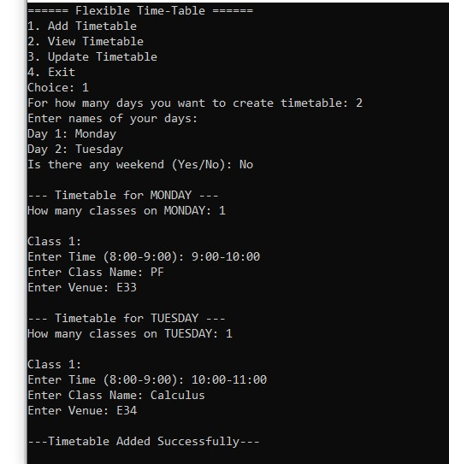

This Program Performed Successfully for all cases. It handled al data efficiently, and produce accurate results and validated all inputs. And the Program required minimal resources.

6.Conclusion, Limitations & References:
Conclusion:
The Flexible Digital Timetable System successfully demonstrates the application of basic programming principles. It minimizes human error, helps in managing the data effectively, displays clear results and is easily editable. The project strengthened understanding of arrays, loops, conditional statements, and functions.
Limitations:
- When the program is closed, it loses all its data (No file handling yet).
- Purely Console based ( No graphical interface).
Future Enhancements:
- Add file handling to save records permanently.
- Implement a graphical interface.
References:
- Apna College by Shraddha Khapra
- https://www.w3schools.com/c/

